*Marposs introduces Ultra Wideband technology*

No interference for optimal process quality

Marposs introduces at EMO the **Ultra Wideband technology**. Visit our booth (hall 6, stand B52) to learn more about the Marposs Ultra Probing system.

The main objective of the touch probing systems is to **optimize the production process of the machine tools, increasing both quality and quantity**: the automatic detection of the machines axes’ position offers advantages in terms of positioning and control of the workpieces, directly in the machining center and the milling machines. For this reason, the probes are mounted directly on the machine spindle, that’s why a wireless signal transmission is necessary, typically based on the 2.4 GHz frequency band.

In recent years, there has been an exponential increase in Wi-Fi devices within production plants, not only smartphones, tablets, and modems, but also automatic elevators and other material handling systems. This leads to saturation of the 2.4 GHz band with the inevitable presence of noise and interference, affecting the reliability of wireless probing systems, causing downtime, and, more generally, decreasing the quality of the production process.

Marposs, always looking for new technologies to meet the growing market demands, can offer something more. Marposs Ultra Probing System is the new touch probing system with Ultra Wideband technology, a real revolution for the machine tool industry. Thanks to the Ultra Wideband technology, Marposs can place itself at a higher level of transmission than the standard, offering a new solution unmatched in terms of performance and reliability.

The most important feature, which is the main advantage introduced by the Marposs Ultra Probing system, is the use of a different transmission range: in Ultra Wideband, **no other physical signal can interfere with the Marposs device, which means no interference and no machine downtime.**

In addition, the system also features many improvements in its design. The anchor is the receiving antenna with an **ultra-compact design** that makes installation easier and faster. It also has 3 LED indicators. The anchor is connected to the machine's CNC by a wired cable. In all systems, the connection is a weak point due to the sealing in a wet area which depends on proper mounting and then directly on the ability of the operator

Marposs Ultra Probing System introduces a new generation of wireless connectors with an extreme level of sealing due to its design, which does not depend on external operations.

In addition, the **new Marposs APP** - which allows system set up and real-time monitoring, combined with diagnostic and service operations - makes the system fast and easy to use.

For more information, visit us at our stand at EMO (Hall 6, Stand B52) or visit our website: <https://www.marposs.com>.

**About Marposs**

MARPOSS was founded in 1952 and Mr. Stefano Possati is the President of the Group; it provides shop-floor solutions for measurement, inspection and testing in the production environment. Marposs’ solutions include gauging equipment of mechanical components, before, during and after the production process; monitoring solutions on machine tools; assembly and testing for many industry sectors; and automatic machines and inspection stations for production lines. MARPOSS is one of the main suppliers to the automotive industry providing solutions for both traditional and electric mobility but additionally operates in the aerospace, biomedical, hi-tech, white appliance, and glass containers industries. MARPOSS Group employs 3500 people around the world and is present in 34 countries with more than 80 sales offices.

**Caption**: Marposs Ultra Probing System is the new touch probing system with Ultra Wideband technology, a real revolution for the machine tool industry.

**Characters with spaces**: 2.737

**Contact**

**Marposs S.p.A.**Martina Battilani  
Via Saliceto, 13   
40010 BENTIVOGLIO (BO) - ITALY  
  
Phone: +39 051 899 719  
Fax: +39 051 899 525  
E-Mail: [martina.battilani@marposs.com](mailto:martina.battilani@marposs.com)

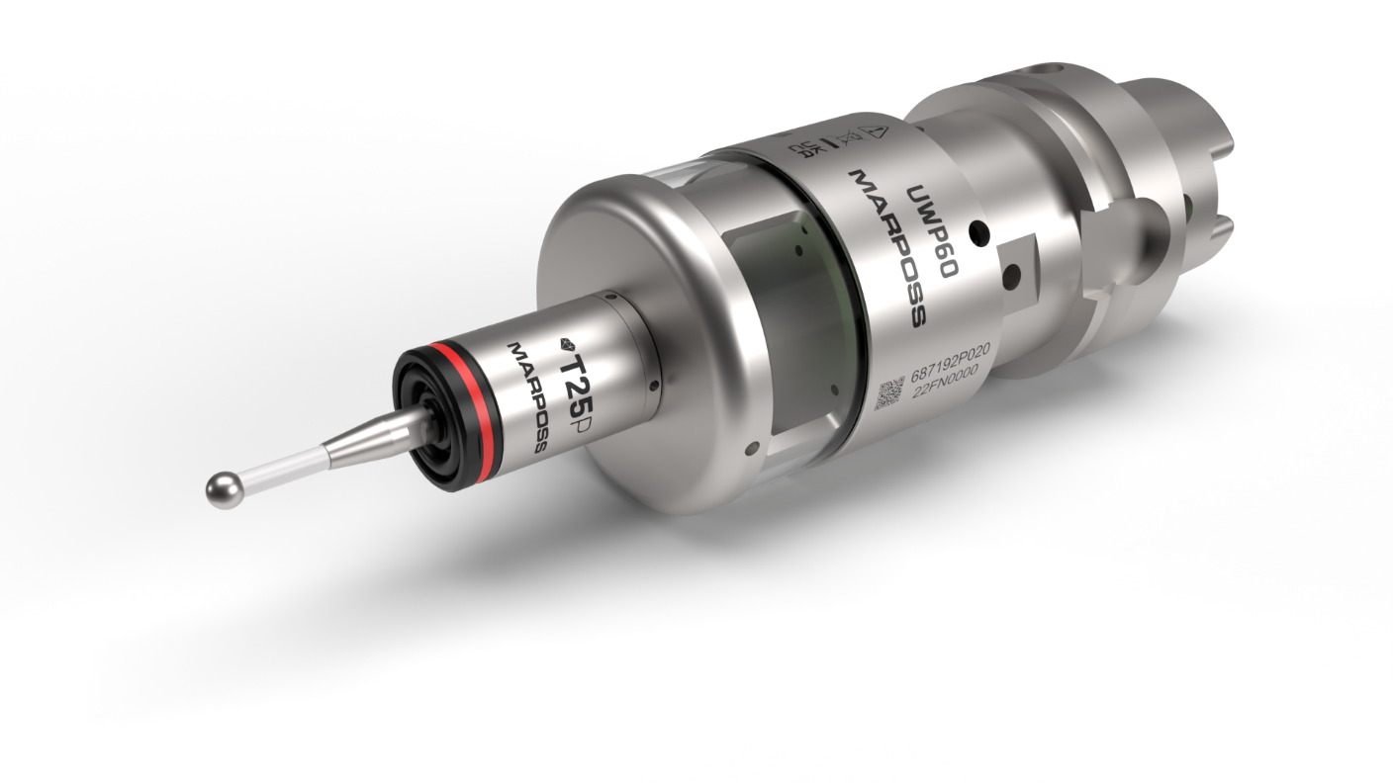

**Image description**:

- Ultra-probing-system.png -> Marposs' new touch probing system with Ultra Wideband technology.